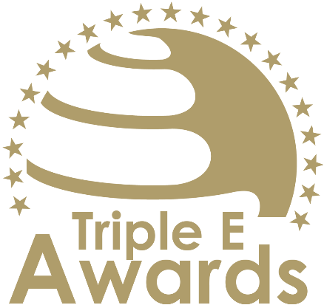



Innovation and Entrepreneurship Activators of the Year

Submission template

African Awards

# About this document

This document has been designed to support the preparation of your entry for the Triple E Awards.

**Key recommendations:**

* Avoid pure “marketing language” but provide a critical evaluation
* Provide clear examples, data and further evidence. Note that you can upload up to 10 pictures during the submission of your entry.

**Checklist:**

[ ] The submission has been prepared in English language

[ ] I responded to all sections of this template

[ ] My responses do not exceed the character/word limits

[ ] I have my organisation’s logo (horizontal logo format) at hand to upload during the submission process (you may also upload your logo in an additional format, for example, squared or vertical logo)

[ ] I have selected one picture that I will upload as the cover image of my entry

[ ] I have selected up to 10 additional pictures (in .jpg or .png format) that can be uploaded together with the information in this template

**How to submit:**

* Visit <https://submission.triple-e-awards.com>
* Create an account
* Click on the “Submit your Entry Now” button
* Select the award category you would like to submit your entry to (Step 1)
* Copy the information from this document into the online form (Step 2)
* Upload the cover picture for your entry (Step 3)
* Upload up to 10 pictures for your entry (Step 4)
* Submit your entry by clicking on the respective button (you can view, edit and delete your entry in the entry overview on the submission landing page)

|  |
| --- |
| Award description |

**When filling out this template, keep the description of the Award in mind:**

*“The Innovation and Entrepreneurship Activators of the Year Award celebrates a team that has made exceptional contributions to promoting entrepreneurship and innovation within the realm of higher education. This prestigious accolade is reserved for groups that have demonstrated an outstanding commitment to fostering an entrepreneurial spirit and innovative mindset among students, faculty, and the wider academic community. The award-winning team could comprise educators, administrators, mentors, or any combination of individuals working collaboratively to create an environment conducive to entrepreneurship and innovation. This team stands out for its efforts in developing programs, workshops, competitions, and networks that encourage and support the pursuit of innovative projects and entrepreneurial ventures. Their work is characterized by a passion for innovation, a dedication to mentoring aspiring entrepreneurs, and a commitment to bridging the gap between academic theory and practical application. The ideal team not only inspires and educates but also provides the necessary resources and connections to turn ideas into reality. This award recognizes the team's significant role in cultivating a vibrant entrepreneurial ecosystem within their institution, making a lasting impact on the students and faculty they serve and contributing to the broader field of higher education.”*

|  |
| --- |
| Basic data |

Submission title   
*Insert the name of the nominee (e.g. name of the university, name of the individual, name of the initiative etc.).* (max 100 characters)

|  |
| --- |
| [Insert here] |

Summary   
*Provide a captivating and concise overview of the achievements or qualities that make the nominee stand out, effectively engaging the reader's interest and curiosity.* (max 300 words)

|  |
| --- |
| [Insert here] |

Organisation(s) affiliated with the entry   
*E.g. the university that employs the nominee for an individual award, or universities that jointly developed and implemented an initiative. In case you apply for an institutional award, please insert the university name again.* (max 150 characters)

|  |
| --- |
| [Insert here] |

Background data

|  |  |
| --- | --- |
| **Foundation year of the activation team** *Please specify the year your "activation team" began its work.* (max. 4 characters) | [Please insert here] |
| **Number of people contributing** *Only people contributing on a continuous basis the nominated initiative, ecosystem, course or team (depending on the Award category)* (max. 100 characters) | [Please insert here] |
| **Number of people/organisations impacted** *Total number of people/organisations impacted by the nominated initiative, ecosystem or team since foundation* (max. 100 characters) | [Please insert here] |

|  |
| --- |
| Evaluation questions |

Program Development and Implementation

Assess the team's effectiveness in developing and implementing innovative programs and initiatives that promote entrepreneurship and innovation. Consider the range and relevance of activities such as workshops, seminars, competitions, and mentorship programs. Focus on how these initiatives are tailored to meet the needs of the academic community and foster a supportive environment for aspiring entrepreneurs and innovators. (max. 450 words)

[Please put your response here]

Engagement and Outreach

Evaluate the team's success in engaging and motivating students, faculty, and other members of the academic community. Consider their efforts in outreach, communication, and building awareness about the importance of innovation and entrepreneurship. Assess how well they have created a sense of community and involvement among diverse groups within the university. (max. 450 words)

[Please put your response here]

Innovation in Approach

Analyze the team's innovation in their approach to activating entrepreneurship and innovation. Consider how they have introduced new methods, tools, or strategies to inspire and support the academic community. Evaluate their ability to adapt to changing needs and challenges, and how they have set new standards or best practices in promoting innovation and entrepreneurship in higher education. (max. 450 words)

[Please put your response here]

Impact on Entrepreneurial Culture

Review the tangible impact of the team's activities on fostering an entrepreneurial culture within the institution. Focus on measurable outcomes such as the number of start-ups formed, the growth of student and faculty involvement in entrepreneurial activities, and the successful transition of projects from ideas to implementation. (max. 450 words)

[Please put your response here]