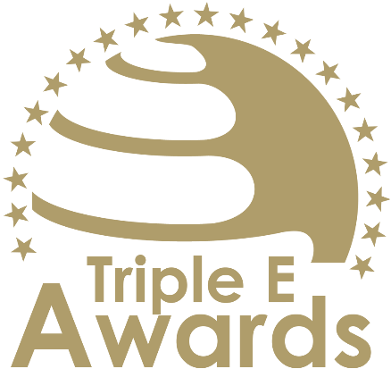



EU Project of the Year

Submission template

European Awards

# About this document

This document has been designed to support the preparation of your entry for the Triple E Awards.

**Key recommendations:**

* Avoid pure “marketing language” but provide a critical evaluation
* Provide clear examples, data and further evidence. Note that you can upload up to 10 pictures during the submission of your entry.

**Checklist:**

[ ] The submission has been prepared in English language

[ ] I responded to all sections of this template

[ ] My responses do not exceed the character/word limits

[ ] I have my organisation’s logo (horizontal logo format) at hand to upload during the submission process (you may also upload your logo in an additional format, for example, squared or vertical logo)

[ ] I have selected one picture that I will upload as the cover image of my entry

[ ] I have selected up to 10 additional pictures (in .jpg or .png format) that can be uploaded together with the information in this template

**How to submit:**

* Visit <https://submission.triple-e-awards.com>
* Create an account
* Click on the “Submit your Entry Now” button
* Select the award category you would like to submit your entry to (Step 1)
* Copy the information from this document into the online form (Step 2)
* Upload the cover picture for your entry (Step 3)
* Upload up to 10 pictures for your entry (Step 4)
* Submit your entry by clicking on the respective button (you can view, edit and delete your entry in the entry overview on the submission landing page)

|  |
| --- |
| Award description |

**When filling out this template, keep the description of the Award in mind:**

*“The EU Project of the Year Award recognizes a currently running or completed project funded by the European Union. This award highlights initiatives that demonstrate exceptional innovation, collaboration, and societal impact, advancing EU priorities and addressing key challenges.”*

|  |
| --- |
| Basic data |

Submission title   
*Insert the name of the nominee (e.g. name of the university, name of the individual, name of the initiative etc.).* (max 100 characters)

|  |
| --- |
| [Insert here] |

Summary   
*Provide a captivating and concise overview of the achievements or qualities that make the nominee stand out, effectively engaging the reader's interest and curiosity.* (max 300 words)

|  |
| --- |
| [Insert here] |

Organisation(s) affiliated with the entry   
*E.g. the university that employs the nominee for an individual award, or universities that jointly developed and implemented an initiative. In case you apply for an institutional award, please insert the university name again.* (max 150 characters)

|  |
| --- |
| [Insert here] |

Background data

|  |  |
| --- | --- |
| **Foundation year** *Please insert when your university, initiative, ecosystem, alliance, research project/stream etc. was established (depending on your category).* (max. 4 characters) | [Please insert here] |
| **Number of project partners** *Total number of organisations that jointly undertake the project* (max. 2 characters) | [Please insert here] |
| **Number of people contributing** *Only people contributing on a continuous basis the nominated initiative, ecosystem, course or team (depending on the Award category)* (max. 100 characters) | [Please insert here] |
| **Number of people/organisations impacted** *Total number of people/organisations impacted by the nominated initiative, ecosystem or team since foundation* (max. 100 characters) | [Please insert here] |

|  |
| --- |
| Evaluation questions |

Alignment with EU Priorities and Goals

Assesses the extent to which the project aligns with and supports the strategic priorities and goals of the European Union. This includes fostering sustainability, digital transformation, social inclusion, innovation, or other key objectives that contribute to the EU’s vision for a resilient and equitable future. (max. 450 words)

[Please put your response here]

Innovation and Creativity in Project Design

Describe how the consortium conceptualizes and implements forward-thinking approaches to address challenges in novel ways. This includes leveraging creative approaches, integrating cutting-edge technologies, and inspiring transformative solutions that set new benchmarks for excellence in higher education and beyond. (max. 450 words)

[Please put your response here]

Collaboration Across Borders and Disciplines

Evaluates the project's ability to foster partnerships that transcend institutional, geographical, and disciplinary boundaries. This includes creating opportunities for interdisciplinary initiatives, international collaborations, and cross-sector engagements that advance knowledge, innovation, and societal impact. (max. 450 words)

[Please put your response here]

Tangible Outcomes and Societal Impact

Describe the measurable results of the project, including improvements within the partner institution and contributions to broader societal challenges. This criterion highlights achievements that demonstrate lasting value, such as fostering sustainable practices, enhancing community well-being, or driving innovation with real-world applications. (max. 450 words)

[Please put your response here]