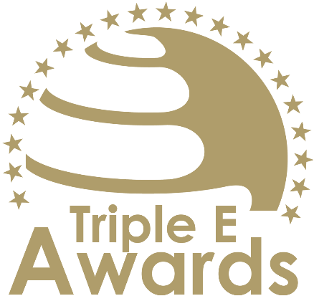



Engaged Research of the Year

Submission template

Global Awards

# About this document

This document has been designed to support the preparation of your entry for the Triple E Awards.

**Key recommendations:**

* Avoid pure “marketing language” but provide a critical evaluation
* Provide clear examples, data and further evidence. Note that you can upload up to 10 pictures during the submission of your entry.

**Checklist:**

[ ] The submission has been prepared in English language

[ ] I responded to all sections of this template

[ ] My responses do not exceed the character/word limits

[ ] I have my organisation’s logo (horizontal logo format) at hand to upload during the submission process (you may also upload your logo in an additional format, for example, squared or vertical logo)

[ ] I have selected one picture that I will upload as the cover image of my entry

[ ] I have selected up to 10 additional pictures (in .jpg or .png format) that can be uploaded together with the information in this template

**How to submit:**

* Visit <https://submission.triple-e-awards.com>
* Create an account
* Click on the “Submit your Entry Now” button
* Select the award category you would like to submit your entry to (Step 1)
* Copy the information from this document into the online form (Step 2)
* Upload the cover picture for your entry (Step 3)
* Upload up to 10 pictures for your entry (Step 4)
* Submit your entry by clicking on the respective button (you can view, edit and delete your entry in the entry overview on the submission landing page)

|  |
| --- |
| Award description |

**When filling out this template, keep the description of the Award in mind:**

*“The Engaged Research of the Year Award honors a research project or initiative that exemplifies outstanding societal impact through meaningful collaboration with communities, organizations, or stakeholders. This award recognizes research efforts that address pressing real-world challenges and make significant contributions to the public good, advancing knowledge in ways that directly benefit society. Honorees demonstrate a commitment to co-creation, inclusivity, and the practical application of research findings to solve complex societal problems.  
  
The award is open to projects that are either completed or currently ongoing.”*

|  |
| --- |
| Basic data |

Submission title   
*Insert the name of the nominee (e.g. name of the university, name of the individual, name of the initiative etc.).* (max 100 characters)

|  |
| --- |
| [Insert here] |

Summary   
*Provide a captivating and concise overview of the achievements or qualities that make the nominee stand out, effectively engaging the reader's interest and curiosity.* (max 300 words)

|  |
| --- |
| [Insert here] |

Organisation(s) affiliated with the entry   
*E.g. the university that employs the nominee for an individual award, or universities that jointly developed and implemented an initiative. In case you apply for an institutional award, please insert the university name again.* (max 150 characters)

|  |
| --- |
| [Insert here] |

Background data

|  |  |
| --- | --- |
| **Foundation year** *Please insert when your university, initiative, ecosystem, alliance, research project/stream etc. was established (depending on your category).* (max. 4 characters) | [Please insert here] |
| **Number of people contributing** *Only people contributing on a continuous basis the nominated initiative, ecosystem, course or team (depending on the Award category)* (max. 100 characters) | [Please insert here] |
| **Number of people/organisations impacted** *Total number of people/organisations impacted by the nominated initiative, ecosystem or team since foundation* (max. 100 characters) | [Please insert here] |

|  |
| --- |
| Evaluation questions |

Societal Relevance and Impact

Explain the tangible benefits and outcomes of the research project for society. Provide evidence of how it has addressed real-world challenges, improved lives, or contributed to the public good in measurable or meaningful ways. (max. 450 words)

[Please put your response here]

Community Collaboration

Describe how the research involved meaningful collaboration with communities or stakeholders. Highlight co-creation efforts, engagement processes, or partnerships that ensured the research was relevant, inclusive, and impactful. (max. 450 words)

[Please put your response here]

Innovation in Research Design and Approach

Showcase the innovative aspects of the research. Highlight creative methodologies, unique solutions, or technologies that enhanced the project’s relevance and effectiveness.
(max. 450 words)

[Please put your response here]

Communication and Dissemination of Results

Describe how the research findings were effectively communicated and shared with diverse audiences. Highlight strategies used to ensure accessibility, such as publications, public engagement activities, digital platforms, or media outreach, and demonstrate how dissemination efforts amplified the research’s impact and relevance to society (max. 450 words)

[Please put your response here]