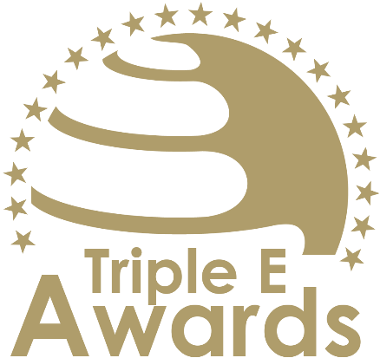



Female Entrepreneurship Empowerment Award

Submission template

Global Awards

# About this document

This document has been designed to support the preparation of your entry for the Triple E Awards.

**Key recommendations:**

* Avoid pure “marketing language” but provide a critical evaluation
* Provide clear examples, data and further evidence. Note that you can upload up to 10 pictures during the submission of your entry.

**Checklist:**

[ ] The submission has been prepared in English language

[ ] I responded to all sections of this template

[ ] My responses do not exceed the character/word limits

[ ] I have my organisation’s logo (horizontal logo format) at hand to upload during the submission process (you may also upload your logo in an additional format, for example, squared or vertical logo)

[ ] I have selected one picture that I will upload as the cover image of my entry

[ ] I have selected up to 10 additional pictures (in .jpg or .png format) that can be uploaded together with the information in this template

**How to submit:**

* Visit <https://submission.triple-e-awards.com>
* Create an account
* Click on the “Submit your Entry Now” button
* Select the award category you would like to submit your entry to (Step 1)
* Copy the information from this document into the online form (Step 2)
* Upload the cover picture for your entry (Step 3)
* Upload up to 10 pictures for your entry (Step 4)
* Submit your entry by clicking on the respective button (you can view, edit and delete your entry in the entry overview on the submission landing page)

|  |
| --- |
| Award description |

**When filling out this template, keep the description of the Award in mind:**

*“The Female Entrepreneurship Empowerment Award recognizes a higher education institution or initiative that has demonstrated exceptional commitment to empowering (future) female entrepreneurs and advancing gender equity in the entrepreneurial ecosystem. This award celebrates programs, networks, or initiatives that effectively address the unique challenges and barriers faced by women in entrepreneurship, such as access to funding, mentorship, and resources. Honorees exhibit innovative approaches to fostering inclusivity, building supportive communities, and creating opportunities for women to thrive as entrepreneurs.”*

|  |
| --- |
| Basic data |

Submission title   
*Insert the name of the nominee (e.g. name of the university, name of the individual, name of the initiative etc.).* (max 100 characters)

|  |
| --- |
| [Insert here] |

Summary   
*Provide a captivating and concise overview of the achievements or qualities that make the nominee stand out, effectively engaging the reader's interest and curiosity.* (max 300 words)

|  |
| --- |
| [Insert here] |

Organisation(s) affiliated with the entry   
*E.g. the university that employs the nominee for an individual award, or universities that jointly developed and implemented an initiative. In case you apply for an institutional award, please insert the university name again.* (max 150 characters)

|  |
| --- |
| [Insert here] |

Background data

|  |  |
| --- | --- |
| **Foundation year** *Please insert when your university, initiative, ecosystem, alliance, research project/stream etc. was established (depending on your category).* (max. 4 characters) | [Please insert here] |
| **Number of people contributing** *Only people contributing on a continuous basis the nominated initiative, ecosystem, course or team (depending on the Award category)* (max. 100 characters) | [Please insert here] |
| **Number of people/organisations impacted** *Total number of people/organisations impacted by the nominated initiative, ecosystem or team since foundation* (max. 100 characters) | [Please insert here] |

|  |
| --- |
| Evaluation questions |

Impact on Female Entrepreneurs

Describe how the initiative has empowered (future) female entrepreneurs by addressing specific barriers such as funding, mentorship, or access to networks. Highlight measurable outcomes, such as increased participation, success rates, or testimonials from participants. (max. 450 words)

[Please put your response here]

Innovation in Program Design

Showcase the unique and creative approaches used to support female entrepreneurs. Provide examples of innovative strategies, tools, or partnerships that distinguish the initiative and enhance its effectiveness. (max. 450 words)

[Please put your response here]

Inclusivity and Community Building

Explain how the initiative fosters an inclusive environment that supports diverse backgrounds, experiences, and perspectives. Highlight efforts to build strong networks and communities that provide ongoing support and collaboration opportunities for female entrepreneurs. (max. 450 words)

[Please put your response here]

Sustainability and Scalability

Outline the long-term viability of the initiative and its potential for expansion. Highlight strategies for ensuring sustained impact and adaptability to different contexts or broader audiences. (max. 450 words)

[Please put your response here]