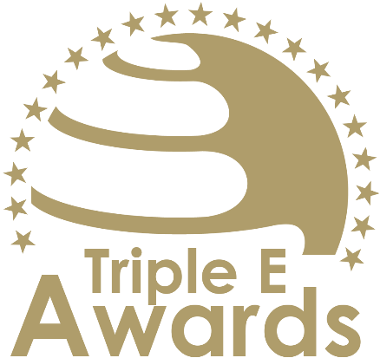



Student-led Impact Initiative of the Year

Submission template

Global Awards

# About this document

This document has been designed to support the preparation of your entry for the Triple E Awards.

**Key recommendations:**

* Avoid pure “marketing language” but provide a critical evaluation
* Provide clear examples, data and further evidence. Note that you can upload up to 10 pictures during the submission of your entry.

**Checklist:**

[ ] The submission has been prepared in English language

[ ] I responded to all sections of this template

[ ] My responses do not exceed the character/word limits

[ ] I have my organisation’s logo (horizontal logo format) at hand to upload during the submission process (you may also upload your logo in an additional format, for example, squared or vertical logo)

[ ] I have selected one picture that I will upload as the cover image of my entry

[ ] I have selected up to 10 additional pictures (in .jpg or .png format) that can be uploaded together with the information in this template

**How to submit:**

* Visit <https://submission.triple-e-awards.com>
* Create an account
* Click on the “Submit your Entry Now” button
* Select the award category you would like to submit your entry to (Step 1)
* Copy the information from this document into the online form (Step 2)
* Upload the cover picture for your entry (Step 3)
* Upload up to 10 pictures for your entry (Step 4)
* Submit your entry by clicking on the respective button (you can view, edit and delete your entry in the entry overview on the submission landing page)

|  |
| --- |
| Award description |

**When filling out this template, keep the description of the Award in mind:**

*“The Student-led Impact Initiative of the Year Award is a prestigious recognition for a student-driven project or initiative that has demonstrated significant, positive impact within the academic community or beyond. This award celebrates initiatives that exemplify innovation, commitment, and effectiveness in addressing key challenges or opportunities. Whether it's through social entrepreneurship, community service, sustainability efforts, or other impactful endeavours, the awarded initiative stands as a testament to the power of student leadership and collaboration. Ideal candidates for this award are initiatives that not only show exceptional results but also embody the spirit of student engagement, creativity, and dedication to making a tangible difference in their community or field. This award honours the initiative's contribution to fostering a culture of proactive, positive change led by the student body. We encourage applications from groups of varying structure and formality, from informal collectives to formally established units like student clubs and associations.”*

|  |
| --- |
| Basic data |

Submission title   
*Insert the name of the nominee (e.g. name of the university, name of the individual, name of the initiative etc.).* (max 100 characters)

|  |
| --- |
| [Insert here] |

Summary   
*Provide a captivating and concise overview of the achievements or qualities that make the nominee stand out, effectively engaging the reader's interest and curiosity.* (max 300 words)

|  |
| --- |
| [Insert here] |

Organisation(s) affiliated with the entry   
*E.g. the university that employs the nominee for an individual award, or universities that jointly developed and implemented an initiative. In case you apply for an institutional award, please insert the university name again.* (max 150 characters)

|  |
| --- |
| [Insert here] |

Background data

|  |  |
| --- | --- |
| **Foundation year** *Please insert when your university, initiative, ecosystem, alliance, research project/stream etc. was established (depending on your category).* (max. 4 characters) | [Please insert here] |
| **Number of people contributing** *Only people contributing on a continuous basis the nominated initiative, ecosystem, course or team (depending on the Award category)* (max. 100 characters) | [Please insert here] |
| **Number of people/organisations impacted** *Total number of people/organisations impacted by the nominated initiative, ecosystem or team since foundation* (max. 100 characters) | [Please insert here] |
| **Foundation year** *Please insert when your university, initiative, ecosystem, alliance, research project/stream etc. was established (depending on your category).* (max. 4 characters) | [Please insert here] |
| **Number of people contributing** *Only people contributing on a continuous basis the nominated initiative, ecosystem, course or team (depending on the Award category)* (max. 100 characters) | [Please insert here] |
| **Number of people/organisations impacted** *Total number of people/organisations impacted by the nominated initiative, ecosystem or team since foundation* (max. 100 characters) | [Please insert here] |

|  |
| --- |
| Evaluation questions |

Innovation and Creativity

Describe how your initiative showcases originality and creative problem-solving. Explain the unique aspects of your approach, focusing on any novel strategies or methods you employed. Highlight how your initiative differs from existing solutions or projects and what makes it stand out. (max. 450 words)

[Please put your response here]

Leadership and Teamwork

Outline the structure and dynamics of your team. Describe the roles and contributions of team members, emphasizing leadership skills and collaborative efforts. Share examples of how challenges were overcome and how team members worked together to advance the initiative. (max. 450 words)

[Please put your response here]

Community Involvement and Engagement

Explain how your initiative engaged with the community and relevant stakeholders. Provide details on partnerships, collaborations, and the initiative's impact on community relations. Discuss how the project has fostered a sense of civic responsibility and engagement among students and other community members. (max. 450 words)

[Please put your response here]

Impact and Effectiveness

Detail the specific impacts and outcomes of your initiative. Provide measurable results and evidence of the effectiveness of your project in achieving its goals. Explain how the initiative has addressed the issue or need it was designed to tackle, including any short-term achievements and potential for long-term benefits.  (max. 450 words)

[Please put your response here]