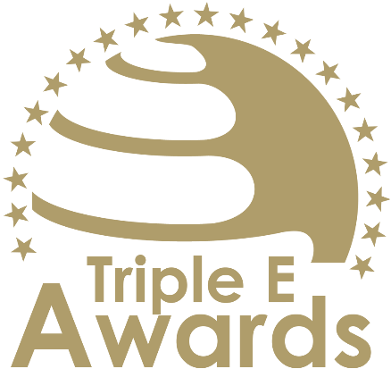



Science Communication Award

Submission template

Global Awards

# About this document

This document has been designed to support the preparation of your entry for the Triple E Awards.

**Key recommendations:**

* Avoid pure “marketing language” but provide a critical evaluation
* Provide clear examples, data and further evidence. Note that you can upload up to 10 pictures during the submission of your entry.

**Checklist:**

[ ] The submission has been prepared in English language

[ ] I responded to all sections of this template

[ ] My responses do not exceed the character/word limits

[ ] I have my organisation’s logo (horizontal logo format) at hand to upload during the submission process (you may also upload your logo in an additional format, for example, squared or vertical logo)

[ ] I have selected one picture that I will upload as the cover image of my entry

[ ] I have selected up to 10 additional pictures (in .jpg or .png format) that can be uploaded together with the information in this template

**How to submit:**

* Visit <https://submission.triple-e-awards.com>
* Create an account
* Click on the “Submit your Entry Now” button
* Select the award category you would like to submit your entry to (Step 1)
* Copy the information from this document into the online form (Step 2)
* Upload the cover picture for your entry (Step 3)
* Upload up to 10 pictures for your entry (Step 4)
* Submit your entry by clicking on the respective button (you can view, edit and delete your entry in the entry overview on the submission landing page)

|  |
| --- |
| Award description |

**When filling out this template, keep the description of the Award in mind:**

*“The Science Communication Award celebrates a higher education institution or individual that demonstrates exceptional skill and dedication in translating complex scientific concepts into accessible, engaging, and meaningful narratives for diverse audiences. This award recognizes innovative approaches to promoting science literacy, inspiring curiosity, and fostering a deeper public appreciation for science and its role in society. Honorees excel in breaking down barriers between academia and the public, using creative methods such as multimedia storytelling, public lectures, community engagement, or digital platforms to connect with people from all walks of life. The award emphasizes the importance of clear, impactful communication in enhancing trust in science, addressing misinformation, and encouraging informed decision-making. By showcasing outstanding achievements in science communication, this award highlights the transformative power of education and outreach in shaping a more scientifically literate and engaged society.”*

|  |
| --- |
| Basic data |

Submission title   
*Insert the name of the nominee (e.g. name of the university, name of the individual, name of the initiative etc.).* (max 100 characters)

|  |
| --- |
| [Insert here] |

Summary   
*Provide a captivating and concise overview of the achievements or qualities that make the nominee stand out, effectively engaging the reader's interest and curiosity.* (max 300 words)

|  |
| --- |
| [Insert here] |

Organisation(s) affiliated with the entry   
*E.g. the university that employs the nominee for an individual award, or universities that jointly developed and implemented an initiative. In case you apply for an institutional award, please insert the university name again.* (max 150 characters)

|  |
| --- |
| [Insert here] |

Background data

|  |  |
| --- | --- |
| **Total audience reached** *(Expected) number of individuals reached* (max. 10 characters) | [Please insert here] |

|  |
| --- |
| Evaluation questions |

Clarity and Accessibility

Explain how the communication effectively simplifies complex scientific concepts without losing accuracy. Highlight strategies used to ensure accessibility for diverse audiences, including non-specialists, through clear language, visuals, or other tools. (max. 450 words)

[Please put your response here]

Creativity and Innovation

Showcase the innovative methods or formats used to communicate science. Provide examples of creative approaches, such as interactive media, storytelling, or community-driven projects, that engage audiences and enhance understanding. (max. 450 words)

[Please put your response here]

Impact and Engagement

Describe the measurable impact of the communication efforts, such as increased public interest, improved science literacy, or meaningful engagement. Include evidence like feedback, audience reach, or examples of how the efforts have influenced perceptions or actions. (max. 450 words)

[Please put your response here]

Relevance and Societal Contribution

Highlight how the communication addresses current societal challenges or promotes informed decision-making. Discuss its relevance to pressing scientific issues and its role in building trust and dialogue between science and the public. (max. 450 words)

[Please put your response here]