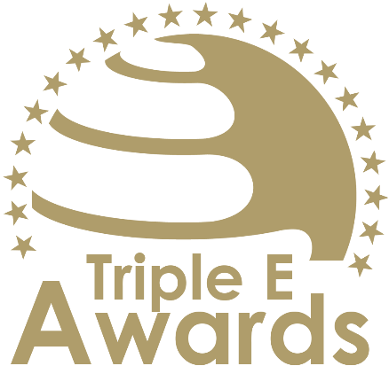



SDG Impact Award

Submission template

Global Awards

# About this document

This document has been designed to support the preparation of your entry for the Triple E Awards.

**Key recommendations:**

* Avoid pure “marketing language” but provide a critical evaluation
* Provide clear examples, data and further evidence. Note that you can upload up to 10 pictures during the submission of your entry.

**Checklist:**

[ ] The submission has been prepared in English language

[ ] I responded to all sections of this template

[ ] My responses do not exceed the character/word limits

[ ] I have my organisation’s logo (horizontal logo format) at hand to upload during the submission process (you may also upload your logo in an additional format, for example, squared or vertical logo)

[ ] I have selected one picture that I will upload as the cover image of my entry

[ ] I have selected up to 10 additional pictures (in .jpg or .png format) that can be uploaded together with the information in this template

**How to submit:**

* Visit <https://submission.triple-e-awards.com>
* Create an account
* Click on the “Submit your Entry Now” button
* Select the award category you would like to submit your entry to (Step 1)
* Copy the information from this document into the online form (Step 2)
* Upload the cover picture for your entry (Step 3)
* Upload up to 10 pictures for your entry (Step 4)
* Submit your entry by clicking on the respective button (you can view, edit and delete your entry in the entry overview on the submission landing page)

|  |
| --- |
| Award description |

**When filling out this template, keep the description of the Award in mind:**

*“The SDG Impact Award recognizes an initiative within higher education that has made a significant and measurable contribution to advancing the United Nations Sustainable Development Goals (SDGs). This award celebrates exemplary efforts that align with global sustainability priorities, addressing pressing challenges such as poverty, inequality, climate change, and quality education. It highlights initiatives that drive meaningful change, foster innovative solutions, and inspire others to take action in creating a more sustainable and equitable future. By showcasing leadership and impact, this award underscores the transformative potential of higher education initiatives in advancing the global sustainability agenda.”*

|  |
| --- |
| Basic data |

Submission title   
*Insert the name of the nominee (e.g. name of the university, name of the individual, name of the initiative etc.).* (max 100 characters)

|  |
| --- |
| [Insert here] |

Summary   
*Provide a captivating and concise overview of the achievements or qualities that make the nominee stand out, effectively engaging the reader's interest and curiosity.* (max 300 words)

|  |
| --- |
| [Insert here] |

Organisation(s) affiliated with the entry   
*E.g. the university that employs the nominee for an individual award, or universities that jointly developed and implemented an initiative. In case you apply for an institutional award, please insert the university name again.* (max 150 characters)

|  |
| --- |
| [Insert here] |

Background data

|  |  |
| --- | --- |
| **Foundation year** *Please insert when your university, initiative, ecosystem, alliance, research project/stream etc. was established (depending on your category).* (max. 4 characters) | [Please insert here] |
| **Number of people contributing** *Only people contributing on a continuous basis the nominated initiative, ecosystem, course or team (depending on the Award category)* (max. 100 characters) | [Please insert here] |
| **Number of people/organisations impacted** *Total number of people/organisations impacted by the nominated initiative, ecosystem or team since foundation* (max. 100 characters) | [Please insert here] |

|  |
| --- |
| Evaluation questions |

Alignment with SDGs

Explain how the initiative directly contributes to one or more of the United Nations Sustainable Development Goals. Highlight the specific SDGs addressed and describe the initiative’s alignment with global sustainability priorities. (max. 450 words)

[Please put your response here]

Innovation and Creativity

Showcase the initiative’s innovative approach to solving sustainability challenges. Highlight unique strategies, creative problem-solving, or new technologies used to achieve its objectives. (max. 450 words)

[Please put your response here]

Measurable Impact

Provide evidence of the initiative’s tangible outcomes, including data, testimonials, or other metrics. Describe how the initiative has created meaningful change for its target audience or community in addressing the identified SDGs. (max. 450 words)

[Please put your response here]

Scalability and Replicability

Outline the potential for the initiative to be scaled or adapted to other contexts or communities. Highlight strategies that ensure the initiative’s sustainability and potential for long-term impact. (max. 450 words)

[Please put your response here]