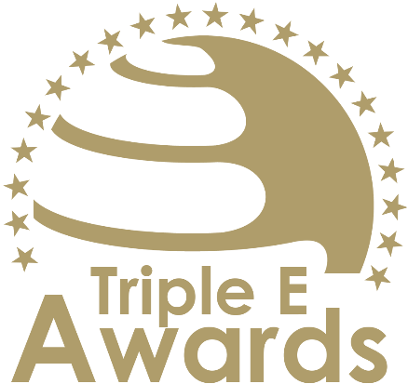



University Alliance of the Year

Submission template

Global Awards

# About this document

This document has been designed to support the preparation of your entry for the Triple E Awards.

**Key recommendations:**

* Avoid pure “marketing language” but provide a critical evaluation
* Provide clear examples, data and further evidence. Note that you can upload up to 10 pictures during the submission of your entry.

**Checklist:**

[ ] The submission has been prepared in English language

[ ] I responded to all sections of this template

[ ] My responses do not exceed the character/word limits

[ ] I have my organisation’s logo (horizontal logo format) at hand to upload during the submission process (you may also upload your logo in an additional format, for example, squared or vertical logo)

[ ] I have selected one picture that I will upload as the cover image of my entry

[ ] I have selected up to 10 additional pictures (in .jpg or .png format) that can be uploaded together with the information in this template

**How to submit:**

* Visit <https://submission.triple-e-awards.com>
* Create an account
* Click on the “Submit your Entry Now” button
* Select the award category you would like to submit your entry to (Step 1)
* Copy the information from this document into the online form (Step 2)
* Upload the cover picture for your entry (Step 3)
* Upload up to 10 pictures for your entry (Step 4)
* Submit your entry by clicking on the respective button (you can view, edit and delete your entry in the entry overview on the submission landing page)

|  |
| --- |
| Award description |

**When filling out this template, keep the description of the Award in mind:**

*“The University Alliance of the Year Award recognizes an alliance of higher education institutions that exemplifies exceptional collaboration in addressing shared challenges and advancing collective goals. This award honors alliances that successfully leverage their combined expertise, resources, and networks to enhance education, research, and service, while fostering innovation and resilience. By working together, these alliances create meaningful and measurable outcomes that benefit students, faculty, and communities, and contribute to tackling pressing global and societal issues. The award celebrates partnerships that demonstrate a commitment to excellence, inclusivity, and long-term impact through effective collaboration.”*

|  |
| --- |
| Basic data |

Submission title   
*Insert the name of the nominee (e.g. name of the university, name of the individual, name of the initiative etc.).* (max 100 characters)

|  |
| --- |
| [Insert here] |

Summary   
*Provide a captivating and concise overview of the achievements or qualities that make the nominee stand out, effectively engaging the reader's interest and curiosity.* (max 300 words)

|  |
| --- |
| [Insert here] |

Organisation(s) affiliated with the entry   
*E.g. the university that employs the nominee for an individual award, or universities that jointly developed and implemented an initiative. In case you apply for an institutional award, please insert the university name again.* (max 150 characters)

|  |
| --- |
| [Insert here] |

Background data

|  |  |
| --- | --- |
| **Foundation year** *Please insert when your university, initiative, ecosystem, alliance, research project/stream etc. was established (depending on your category).* (max. 4 characters) | [Please insert here] |
| **Number of university partners** *Total number of universities in the alliance* (max. 2 characters) | [Please insert here] |
| **Number of students** *Total number oof students of all university partners combined, including part and full-time, and bachelor, master and PhD students* (max. 7 characters) | [Please insert here] |
| **Number of staff members** *Number of staff members of all university partners combined (FTE)* (max. 7 characters) | [Please insert here] |

|  |
| --- |
| Evaluation questions |

Strategic Vision and Collaborative Approach

Describe how the alliance has developed and implemented a shared strategic vision to address common challenges. Highlight the collaborative mechanisms in place, such as joint governance structures, decision-making processes, or shared priorities that ensure effective cooperation among member institutions. (max. 450 words)

[Please put your response here]

Innovative Practices and Solutions

Provide examples of innovative practices or solutions the alliance has implemented to enhance education, research, or societal engagement. Focus on how the alliance has leveraged its collective strengths to pioneer new approaches or address challenges in a creative and impactful way. (max. 450 words)

[Please put your response here]

Tangible Impact on Stakeholders

Detail the specific benefits delivered to students, faculty, and the broader community as a result of the alliance’s activities. Include evidence of measurable outcomes, such as improved access to resources, enhanced learning opportunities, groundbreaking research, or meaningful contributions to societal challenges. (max. 450 words)

[Please put your response here]

Sustainability and Future Growth

Explain how the alliance ensures the long-term sustainability of its initiatives and fosters continuous growth. Describe the strategies and resources in place to maintain and expand its impact, including plans for scaling successful programs or broadening the alliance’s scope of collaboration. (max. 450 words)

[Please put your response here]