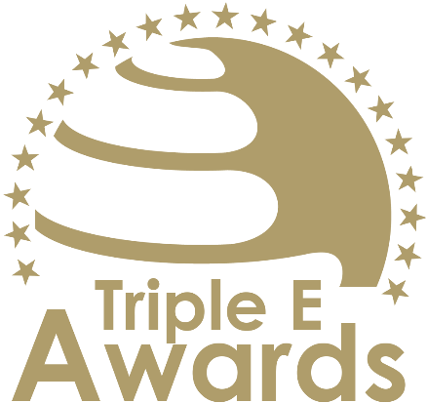



Entrepreneurial Leadership Team of the Year

Submission template

Global Awards

# About this document

This document has been designed to support the preparation of your entry for the Triple E Awards.

**Key recommendations:**

* Avoid pure “marketing language” but provide a critical evaluation
* Provide clear examples, data and further evidence. Note that you can upload up to 10 pictures during the submission of your entry.

**Checklist:**

[ ] The submission has been prepared in English language

[ ] I responded to all sections of this template

[ ] My responses do not exceed the character/word limits

[ ] I have my organisation’s logo (horizontal logo format) at hand to upload during the submission process (you may also upload your logo in an additional format, for example, squared or vertical logo)

[ ] I have selected one picture that I will upload as the cover image of my entry

[ ] I have selected up to 10 additional pictures (in .jpg or .png format) that can be uploaded together with the information in this template

**How to submit:**

* Visit <https://submission.triple-e-awards.com>
* Create an account
* Click on the “Submit your Entry Now” button
* Select the award category you would like to submit your entry to (Step 1)
* Copy the information from this document into the online form (Step 2)
* Upload the cover picture for your entry (Step 3)
* Upload up to 10 pictures for your entry (Step 4)
* Submit your entry by clicking on the respective button (you can view, edit and delete your entry in the entry overview on the submission landing page)

|  |
| --- |
| Award description |

**When filling out this template, keep the description of the Award in mind:**

*“This award celebrates a leadership team in higher education that has excelled in applying entrepreneurial thinking to seize opportunities and deliver impactful outcomes. By embracing creativity, adaptability, and strategic foresight, the team has effectively transformed vision into action, benefiting their institution and society at large.  
  
The leadership team may consist of members from various levels and units, encompassing but not limited to university-wide roles, faculty or school administration, departmental leadership, research unit directors, support unit management, or student leaders.”*

|  |
| --- |
| Basic data |

Submission title   
*Insert the name of the nominee (e.g. name of the university, name of the individual, name of the initiative etc.).* (max 100 characters)

|  |
| --- |
| [Insert here] |

Summary   
*Provide a captivating and concise overview of the achievements or qualities that make the nominee stand out, effectively engaging the reader's interest and curiosity.* (max 300 words)

|  |
| --- |
| [Insert here] |

Organisation(s) affiliated with the entry   
*E.g. the university that employs the nominee for an individual award, or universities that jointly developed and implemented an initiative. In case you apply for an institutional award, please insert the university name again.* (max 150 characters)

|  |
| --- |
| [Insert here] |

Background data

|  |  |
| --- | --- |
| **Team start year** *Year the team started working together* (max. 4 characters) | [Please insert here] |

|  |
| --- |
| Evaluation questions |

Opportunity Identification and Strategic Vision

Describe how your team has identified and acted upon emerging opportunities. Highlight examples of how you have demonstrated creativity, strategic foresight, and a proactive approach in aligning these opportunities with your institution’s long-term goals. (max. 450 words)

[Please put your response here]

Implementation and Realization of Initiatives

Detail the key initiatives your team has successfully implemented, outlining the steps taken to transform vision into action. Include information on planning, resource allocation, and any measurable outcomes or results that demonstrate the success of your efforts. (max. 450 words)

[Please put your response here]

Collaboration and Partnerships

Share how your team has fostered collaborations across disciplines, sectors, or communities to enhance the effectiveness and reach of your initiatives. Provide examples of partnerships that have been integral to realizing opportunities and creating shared value. (max. 450 words)

[Please put your response here]

Impact and Sustainability

Explain the impact your team’s efforts have had on your institution and broader society. Highlight the tangible and intangible outcomes of your work, and describe how your initiatives have been designed for long-term sustainability and scalability. (max. 450 words)

[Please put your response here]